Task 3.2:

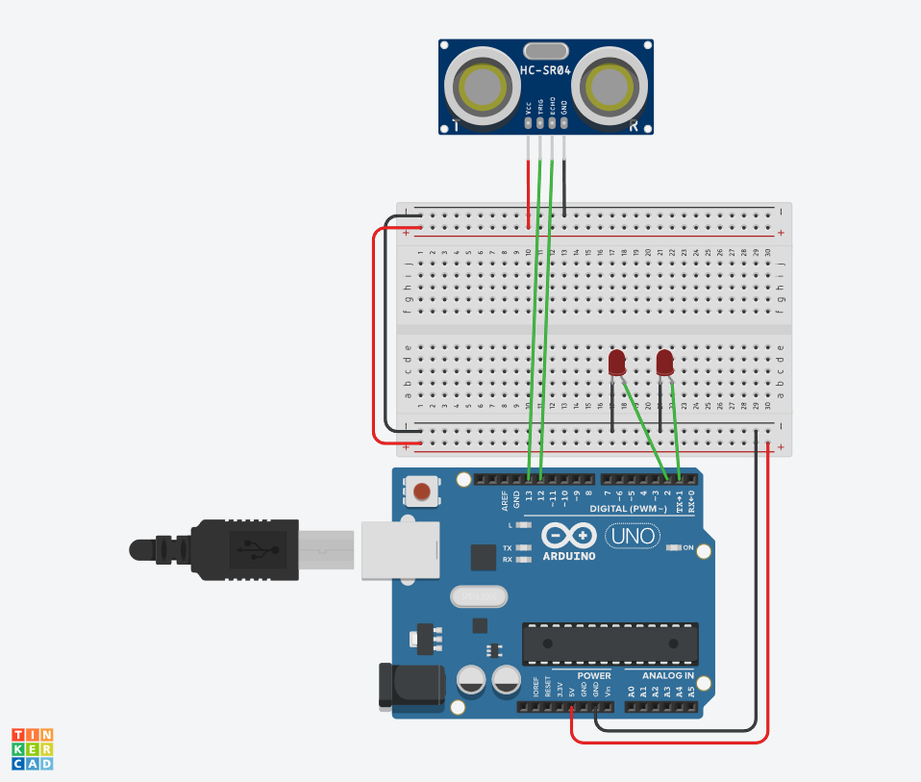
Diagram:

Video link: https://deakin.au.panopto.com/Panopto/Pages/Viewer.aspx?id=421a0407-5830-491a-9be1-b411004f55e7

GitHub link: https://github.com/charlieM044/SIT210

